Final draft agenda (version of March 1st)

Meeting time:
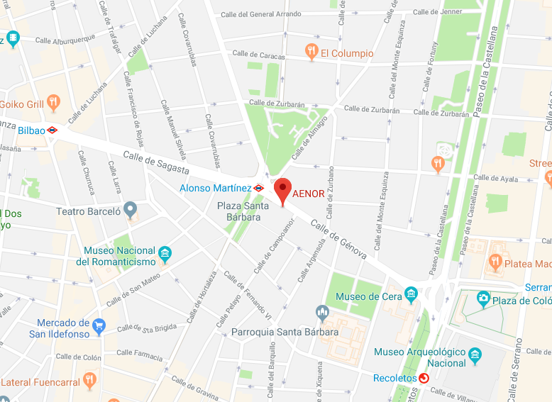
Wednesday, March 7th, 2018, 14:00 - 18:00
Meeting location:
AENOR
Calle de Génova, 6, 28004 Madrid, Spain
Meeting room: 1.1+1.2
Phone: +34 915 294 900

Web conference login - see below agenda

Recommended hotels – see below agenda

Related meetings same place:
- CEN TC 312 WG 1 “Solar collectors”
- IEA SHC Task 57 “Solar Standards and Certification”
- Global Solar Certification Network, GSCN
see overview/time schedule of meetings below agenda

Registration deadline 20th February
Note: If the below on-line registration form below does not work for you,
please fill in the last page in this document and send to jen@solarkey.dk

Link to: On-line registration*

*) Registrations for meetings in Solar Keymark Network, GSCN and IEA SHC Task 57 can be done here. Registration for the CEN TC312 WG1 meeting is done with CEN TC 312 secretariat. If this Google link does not work in your country please fill in registration template on last page

Global Solar Certification Network, March 7th, 14:30 – 18:00
Item | Decision/-resolution requested | Topic/content/responsible | Related documents / comments / details
1 |  | Short welcome and roll call of participants / HD  Approval of agenda
2 |  | Minutes of last meeting / JE  Minutes of last board meeting | N0061.R0--meeting report  N0066.R0-Report from Board meeting
3 |  | Status on members of GSCN  List of observers / informal members  Formal members  Voting/election rights as proposed by the board:  - To vote – you shall have applied for membership (at latest at the meeting)  - To candidate for a board position – you shall have applied for membership (before the meeting) | http://gscn.solar/members/list%20of%20members.html
4 | x | Election of board members. Existing board members:  Continent Africa & MENA region Asia Europe North America Oceania South America  Manufacturer Xiaowen Zhou Harald Poscharnig Jeremy Osborne  Qingtai Jiao ?  Certification body Xiaochao Tong? Sören Scholz ? Les Nelson  Lin Jiali ? Shawn Martin  Test lab He Tao Harald Drück  James Huang Korbinian Kramer  Persons in bold can be re-elected  Chair: Harald Drück  New candidates:  …
5 | x | Election of QAC members. Existing QAC memberss:  Continent Africa & MENA Asia Europe North America Oceania South America  Certification body Shawn Martin  Sören Scholz ?  Test lab Zheng Ruicheng Carsten Lampe  He Zinian ? Stephan Fischer  Stefan Mehnert  Chair: Shawn Martin  New candidates:  …
6 | x | Appointing/electing new manager from 2019  Process for appointing/electing new manager to be agreed..  Candidates :  Shawn Martin ? – answer by the end of the month  Vassiliki Drosou ? – to be asked
7 | x | GSCN Working Rules (main part)  Proposals for revisions / Proposals for resolutions? | N0001.R25
8 | x | GSCN Working Rules Annexes A: Requirements for certification bodies, inspection bodies / inspectors and test labs/ JEN  Proposals for revisions / Proposals for resolutions? | N0001A.R7
9 | x | GSCN Working Rules Annex B1: Collector data sheet template / JE  Proposals for revisions / Proposals for resolutions? | N0001B1.R7
10 | x | GSCN Working Rules Annex B2: Inspection report template / J. Fernandez / S. Fischer  Proposals for revisions / Proposals for resolutions? | N0001B2.R5
11 | x | GSCN Working Rules Annex C1: Requirements for factory production control / J. Fernandez / S. Fischer  Proposals for revisions / Proposals for resolutions? | N0001C1.R5
12 | x | GSCN Economy  Presentation of economy status - approval  Proposal for decision: The agreed economy status for 2017 is approved  Presentation of draft budget proposal – discussion – revision - approval  Proposal for decision: The agreed budget for 2018 is approved  GSCN Working Rules Annex D: Fees/ JEN  Presentation of Annex D of working rules  Proposals for resolutions?  GSCN Working Rules Annex F: GSCN Finance Policy  Presentation of Annex F of working rules  Proposals for resolutions? | GSC_N0065.R1_EconomyStatus-18-03-01.xlsx  GSC_N0057.R5_budget_proposal_2018.xlsx  N0001D.R1  GSC_N0001F.R2-FinancePolicy.docx
13 | x | GSCN Working Rules Annex E: Template for signing up for the Global Solar Certification Network / JEN  Presentation of Annex E of working rules  Discussion of ideas for improvements  Proposals for resolutions? | N0001E.R1
14 | x | New annex: Confirmation of Membership | GSC_N0064.R2_MemberConfirmation.docx
15 |  | Status of web site / JE | http://www.gscn.solar
16 | x | Establish formally the Global Solar Certification Network as a non-profit international association based on the working rules described in the document GSC_N0001.R25 dated 07/03/2017 and the annexes A – F ?  Discussion / decision ?
17 |  | Tasks for the GSCN Quality Assurance Committee (QAC) / SM | Presentation
18 |  | Promotion of GSCN / HD  Co-operation with Bärbel Epp  The Bärbel Epp proposal for “GSCN promotion” is given here:  The promotion activities I suggested in Abu Dhabi are listed in the following:  - Solrico drafts an introduction letter for collector manufacturers based on the attached news, but more personal (the text will be approved by both of you).  - Solrico sends the letter out to the around 550 collector manufacturers of the solrico database (built up from the world map of collector manufacturers over the years)  - Solrico gathers the answers from this mailing (will be probably only a few direct answers)  - Solrico selects the 30 largest and/or globally active collector manufacturer (list will be approved by both of you) and contact them by phone to follow up after the mailing and to find out about their interest in becoming GSCN member (carried out by solrico).  - Solrico delivers a table with a summary of the calls and the contact information for all interested companies  - Interested companies will then be contacted by one of you.  The scope covers two working days à 850 EUR equalling to 1,700 EUR.  To be financed 50 % from GSCN account (50 % co-financing offered by Harald Drück)
19 |  | Solergy Label / JEN  - Presentation  - Discussion – could be connected to GSCN? | GSC_N0067.R0-SOLERGY-presentation
20 |  | Meetings 2018 /JEN  - GSCN meeting: March 7th 14:00 – 18:00 (now)  - IEA SHC Task 57: March 8th 9:00 – 18:00  - ExCo meeting: June 19th – June 21st / Gothenburg, Sweden  - IEA SHC Task 57: Monday 10th September, Switzerland (SPF) / Eurosun Conference 11-12th, ISO TC 180 12-13th September  - ExCo meeting: 13th – 15th November / Portugal  - GSCN meeting: Wednesday 6th March 14 – 19, 2019, Gothenburg, Sweden (after SKN meeting)  - Others ? | Task 57 Agenda
21 |  | Misc.
 |  | 18:00 End of meeting
 |  | Optional common dinner

Login info for web attendees:
https://attendee.gotowebinar.com/register/5326092987849238273

Meeting plan | Madrid, March 2018
MEETING | Tuesday 6th March |  |  | Wednesday 7th March |  |  | Thursday 8th March | Estimated no. people | Meeting room
 | 9 - 12 | 12 - 13 | 13 - 19 | 9 - 13 | 13 - 14 | 14 - 18 | 9 - 18
CEN 312 WG1 | WG1 meeting
Solar Keymark Network |  | Lunch | SKN | SKN |  |  |  | 40 | 1.1 + 1.2
GSCN |  |  |  |  | Lunch | GSCN Plenary |  | 30 | 1.1 + 1.2
IEA SHC Task 57 |  |  |  |  |  |  | Task 57 Expert meeting  Subtask A, B, C | 20 | 1.1

Recommended Hotels

A) Hotel Relais Châteaux Orfila *****, www.hotelorfila.com
Calle de Orfila, 6, 28010 Madrid - 917 027 770

B) Hotel Gran Versalles ****, www.hotelgranversalles.es
Calle de Covarrubias, 4, 28010 Madrid - 914 475 700

C) Petit Palace Santa Barbara ****, www.petitpalacesantabarbara.com
Plaza de Sta. Barbara, 10, 28004 Madrid

D) Hotel NH MADRID ALONSO MARTÍNEZ ****, www. nh-hoteles.es
Calle de Sta Engracia, 5, 28010 Madrid - 915 94 02 13

E) Hotel INNSIDE MADRID ****, www. melia.com
Plaza Alonso Martínez, 3, 28004 Madrid - 912 76 47 47

Registration for:
Solar Meetings, March 2018, AENOR, Madrid, Spain

Online registration for one or more of the solar meetings at AENOR, March 6 - March 8
- Solar Keymark Network meeting
- Global Solar Certification Network meeting
- IEA SHC Task 57 expert meeting

*Obligatory

*1. First name:
*2. Last Name:
*3. Company/organization:
*4. Type of organization:

Check only one of the following (put X in front):
Industry/manufacturer
Certification body
Test lab
Inspector / Inspection body
Guest/observer
Other

5. Name of nominating organization:
Only relevant for industry representatives participating in the Solar Keymark Network meeting. Participants from industry shall have nomination from a national industry association in order to atend in the Solar Keymark Network meeting.

*6. Country:

*7. e-mail:

8. Mobile number:

9. Name of hotel:

*10. I will attend
The CEN TC312 WG1 meeting is open for members of CEN TC312 WG1. The Solar Keymark Network meeting is open for network members and invited observers. Please e-mail Chairman Andreas Bohren (Andreas.Bohren@spf.ch) to apply for such invitation. Global Solar Certification Network (GSCN) plenary meeting is open for members and observers. IEA SHC Task 57 meeting is open for task participants and observers.
Check all the activities you want to participate in (put X in front):
Lunch before Solar Keymark Network meeting, Tuesday March 6th, 12:00 - 13:00
Solar Keymark Network meeting, Tuesday March 6th, 13:00 - 19:00
Optional common dinner (self paid), Tuesday March 6th, 20:00
Solar Keymark Network meeting, Wednesday, March 7th, 09:00 - 13:00
Lunch before GSCN plenary meeting (self paid), Wednesday March 7th, 13:00 -14:00
GSCN Plenary meeting Wednesday, March 7th, 14:00 - 18:00
Optional common dinner (self paid), Wednesday March 7th, 20:00
IEA SHC Task 57 meeting, Thursday March 8th, 09:00 - 17:00
Lunch at IEA SHC Task 57 meeting (self paid), Thursday March 8th, 13:00 -14:00
Optional common dinner (self paid), Thursday March 8th, 19:00

